COSC 304 Project
Introduction to Databases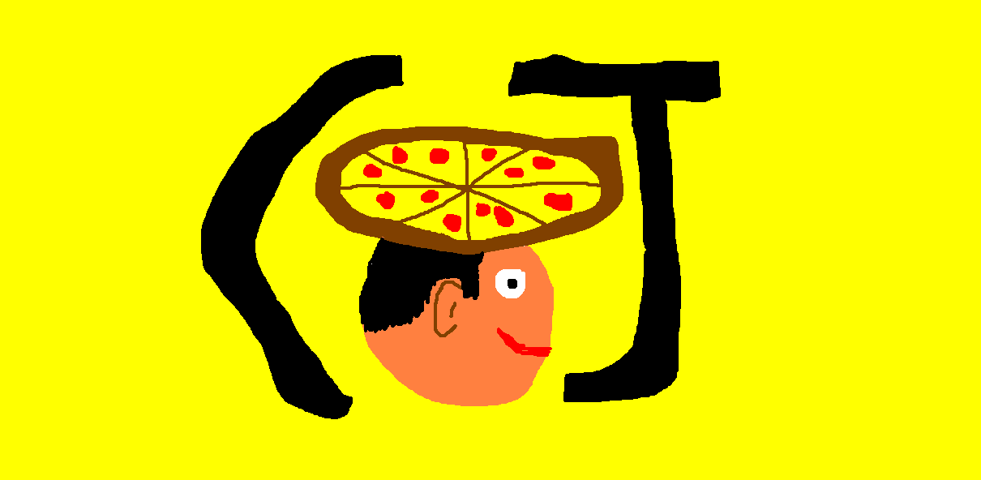
C&J’s Tasty Hats

Cohen Kucher
Jaden Anderson

1. Introduction
1.1 Mission Statement
C&J’s mission is to provide a solution to every hungry hat lover: tasty hats! Our e-shop will allow users to buy whatever tasty hat they desire from beyond their wildest dream because we have an extensive range of tasty hats made only from the freshest ingredients.
1.2 Executive Summary
Hats have been a staple of the human wardrobe for centuries and not without good reason: they shield us from the elements, protect us from our enemies, and most importantly make us look cool.
While we here at C&J’s give respect to all the hats that have come before, we feel that they all share one major fault: the lack of tastiness. To fix this, our shop will sell hats of a yummier variety to the hungry, hatless masses, and enable them to have a tastier and more stylish life.
C%J’s Tasty Hats
Hats With A Taste

2. System Features

Final Overall System Features | Category | Possible Points | Points | Comments / Code Files
Documentation (15 total points)
Executive Summary (up to 1 page) | Required | 2 | 2
System Features (2 pages) | Required | 2 | 2
List of Web and AI sources used | Required | 3 | 3
Walkthrough with screenshots (up to 15 pages) | Required | 8 | 8
Hosting (10 total points)
Running on a cloud server | Advanced | 10 | 10 | https://cjhats.azurewebsites.net/  Running on azure, database is stored in azure as well as the website being hosted on azure
Main/Home Page (up to 14 total points)
Search for a product by name | Core | 1 | 1 | listprod.jsp
Browse products by category | Core | 1 | 1 | listprod.jsp
List products (by search/browse) | Core | 1 | 1 | listprod.jsp
List products with image | Core | 1 | 1 | listprod.jsp  product.jsp
Page header with menu | Basic | 1 |  | index.jsp
Page header shows the current logged-in user | Basic | 1 | 1 | index.jsp
Dynamic products on homepage based on sales | Basic | 2
Improved UI (user-friendly, images, etc.) | Basic | 2 | 2 | Index.jsp, If you wait on this page for a bit the guy blinks!
Product recommendation based on the user | Advanced | 4
Shopping Cart (up to 8 total points)
Add to shopping cart | Core | 1 | 1 | product.jsp  listprod.jsp
View shopping cart | Core | 1 | 1 | addcart.jsp
Update quantity (with data validation) | Basic | 1
Remove item from shopping cart | Basic | 1 | 1 | showcart.jsp
Improved formatting/UI (e.g. in header bar) | Basic | 1
Cart stored in database between sessions | Basic | 3
Checkout (up to 9 total points)
Checkout with customer id | Core | 1 | 1 | checkout.jsp
Checkout with payment/shipment info | Basic | 2
Checkout with data validation | Basic | 2
Multiple shipments per order supported | Advanced | 2
Calculate taxes/shipping (by items/state) | Advanced | 2
Product Detail Page (up to 2 total points)
Product detail page and item description | Core | 1 | 1 | product.jsp
Product detail has an image from database | Core | 1 | 1 | product.jsp
Points:
User Accounts/Login (up to 12 total points)
Create user account page | Basic | 2 | 2 | register.jsp
Create account with data validation | Basic | 2 | 2 | register.jsp
Edit user account info (address, password) | Basic | 2 | 2 | account.jsp  changeUsername.jsp  changePassword.jsp
Login/logout | Core | 1 | 1 | login.jsp
Register user/Forgot password email | Advanced | 4
Page listing all orders for logged in user | Basic | 1 | 1 | account.jsp
Product Reviews (up to 5 total points)
Ability to enter a review on a product | Basic | 2
Display product review on product detail page | Basic | 1
Restrict to one review per user on item purchased | Advanced | 2
Warehouses/Inventory (up to 5 total points)
Display item inventory by store/warehouse | Basic | 2
Edit item inventory by store/warehouse | Advanced | 3
Administrator Portal (up to 18 total points)
Secured by login | Core | 1 | 1 | All the account related pages
List all customers | Basic | 1
List report showing total sales/orders | Basic | 1
Report with a graph | Advanced | 3
Add new product | Basic | 2 | 2 | admin.jsp  addProduct.jsp
Update/delete product | Basic | 2
Change order status/ship order | Basic | 1
Upload a photo to file system for product | Advanced | 2
OR: Upload a photo to database for product | Advanced | 4
Database restore with SQL script | Core | 1 | 1
Add/update warehouse, customer | Basic | 2
Database System/General
Implement some validation using triggers | Advanced | 2
Use JavaScript validation for some pages | Advanced | 4
User interface and navigation/usability |  | Up to 5
Others (your suggestions) |  | Up to 5
Total: (out of 50 with maximum of 10 bonus marks. i.e. 60 points out of 50 is max.) |  |  | 50

3. Sources
https://github.com/rlawrenc/cosc_304/tree/main
https://chatgpt.com/
https://learn.microsoft.com/en-us/azure/?product=popular

4. Links and Passwords

- Link to the site: https://cjhats.azurewebsites.net/
- Username for example user: arnold
- Password for example user: 304Arnold!
  - (Or just register your own user!)

5. Project Walkthrough

Our project starts on the Main Page where users are given options to login, begin shopping, list all the previous orders, view customer information, view the administrators page, log out, and their account info if not logged in and an option to register an account. It also shows the name that you are signed into, and shows a really cool logo and main text. | 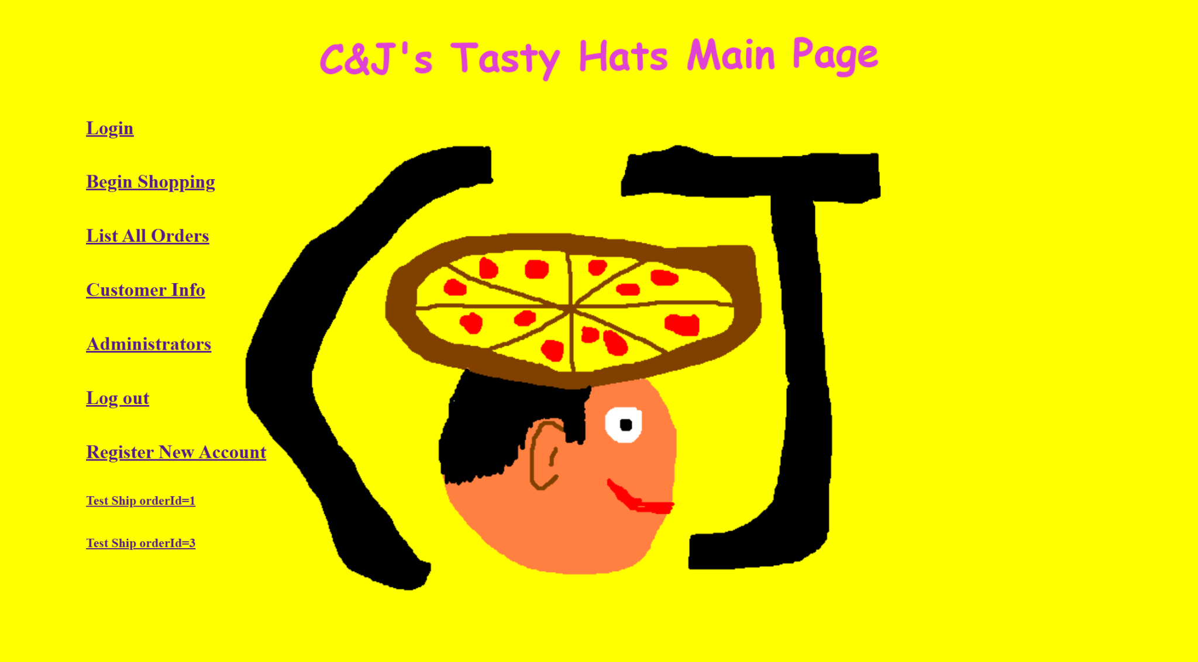
If the user clicks the login button they will be taken to a screen that prompts them to put in their username and password. If they put in a combination that is in the database they are logged in and taken to the main screen. If they put in the wrong information they are prompted to try again | 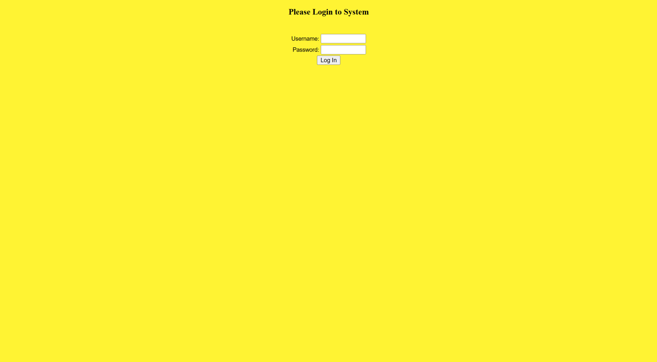
From the main page, If the user clicks the begin shopping button they are taken to a page that lists our inventory of tasty hats as well as a search bar to search for a specific hat. Users can click on the name of the hat for a description of it and they can also click add to cart to directly add it to the cart. | 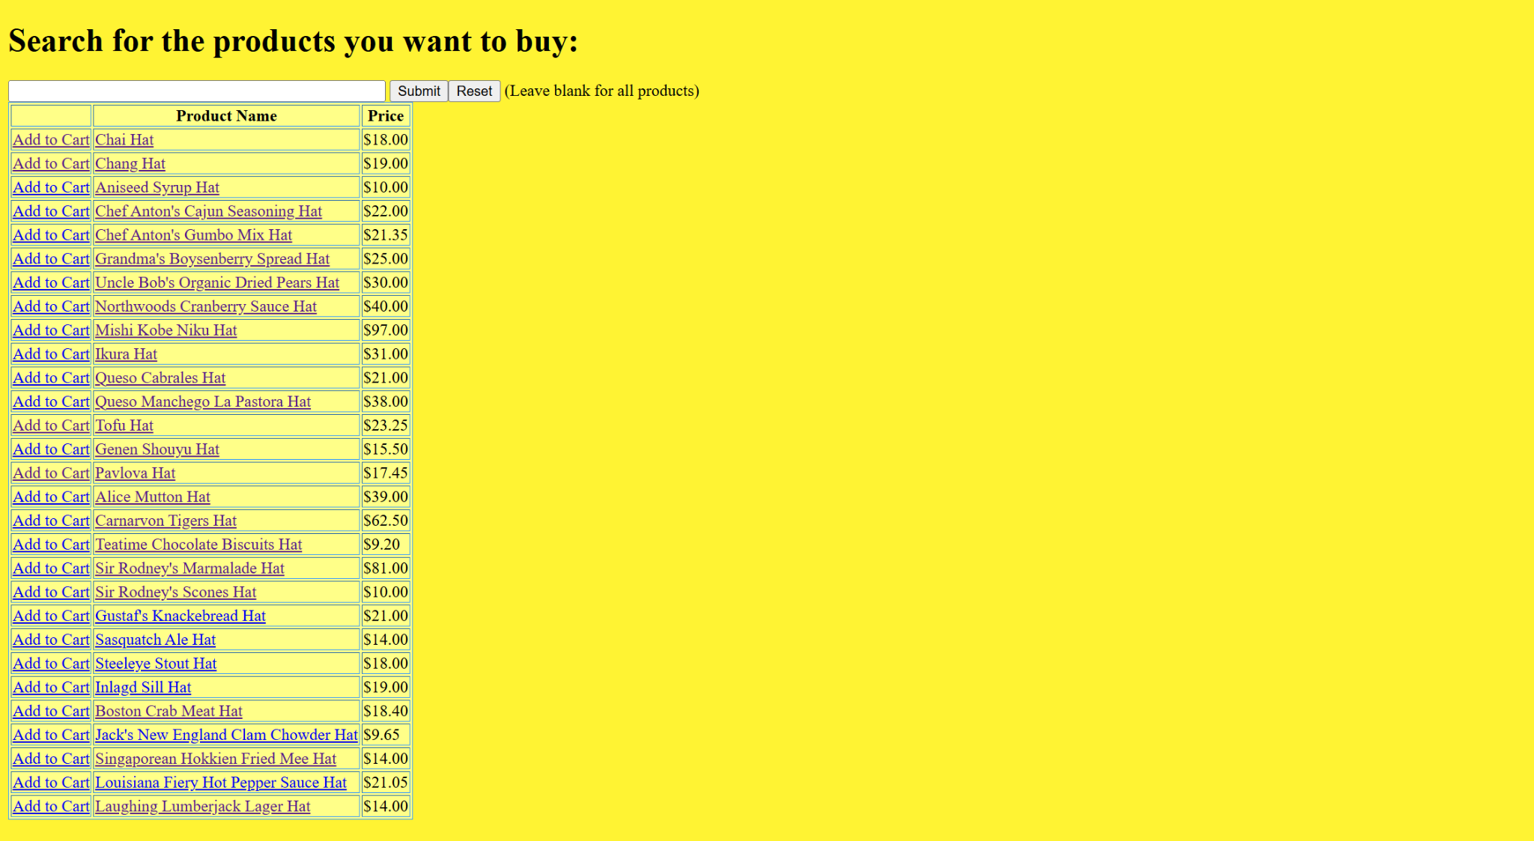
From the product list page if a user clicks on a hat name they are taken to an overview with a description of the hat as well as an image of it. There are two links at the bottom one takes the user to the add to cart screen and the other takes the user to continue shopping | 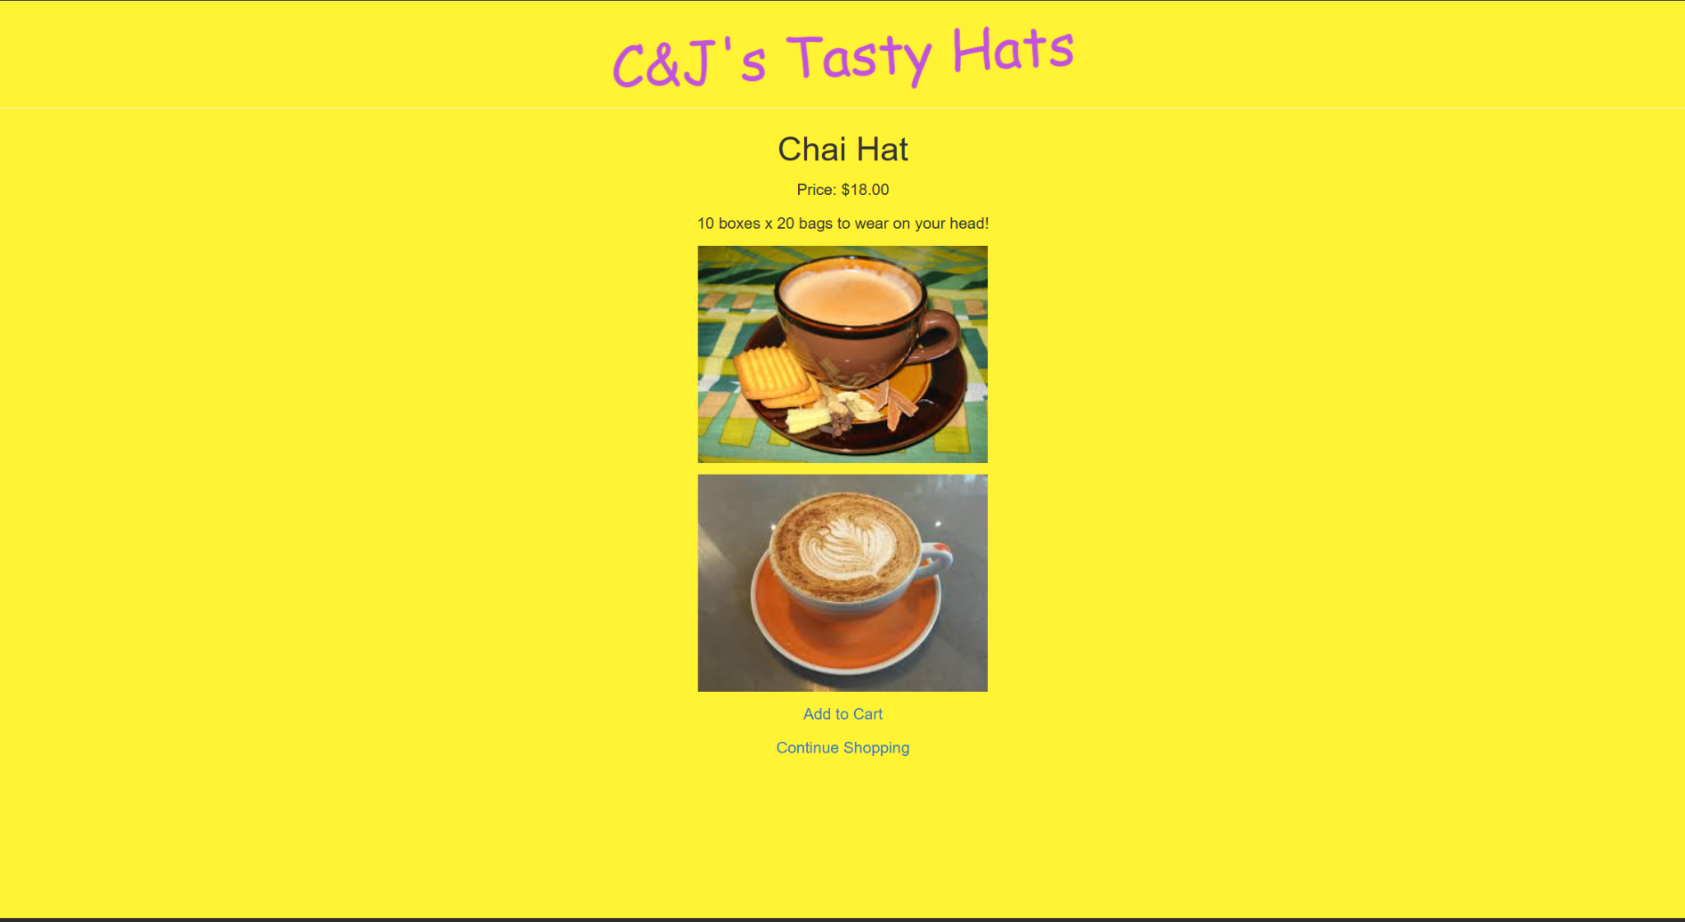
From either the product listing page page or the product overview page if the user clicks the add to cart button they are taken to the cart page. There they can see a list of the products in their cart and are given an option to checkout or continue shopping. | 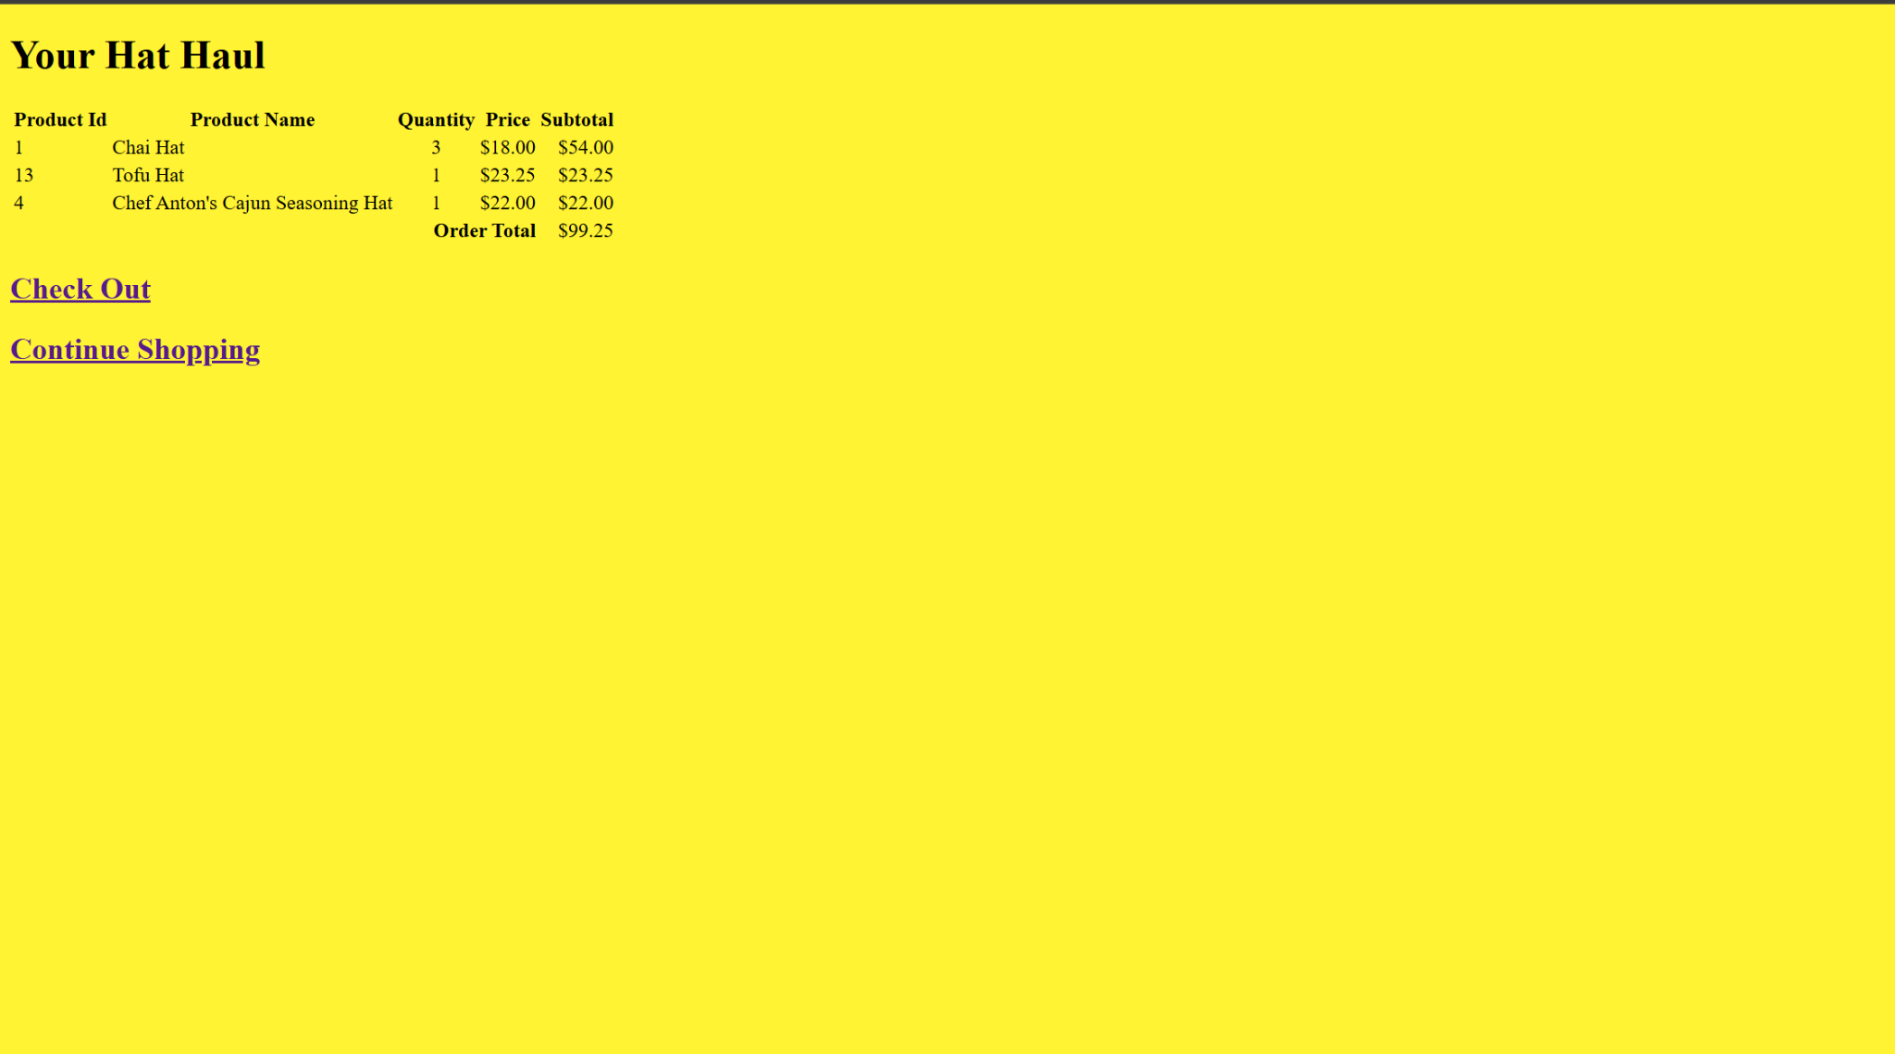
If the user then clicks the checkout button they are prompted to enter their customer ID as well as their password, and once correctly inputted they are taken to their order summary page which is essentially the same as the cart page but with a confirmation that they have placed an order. | 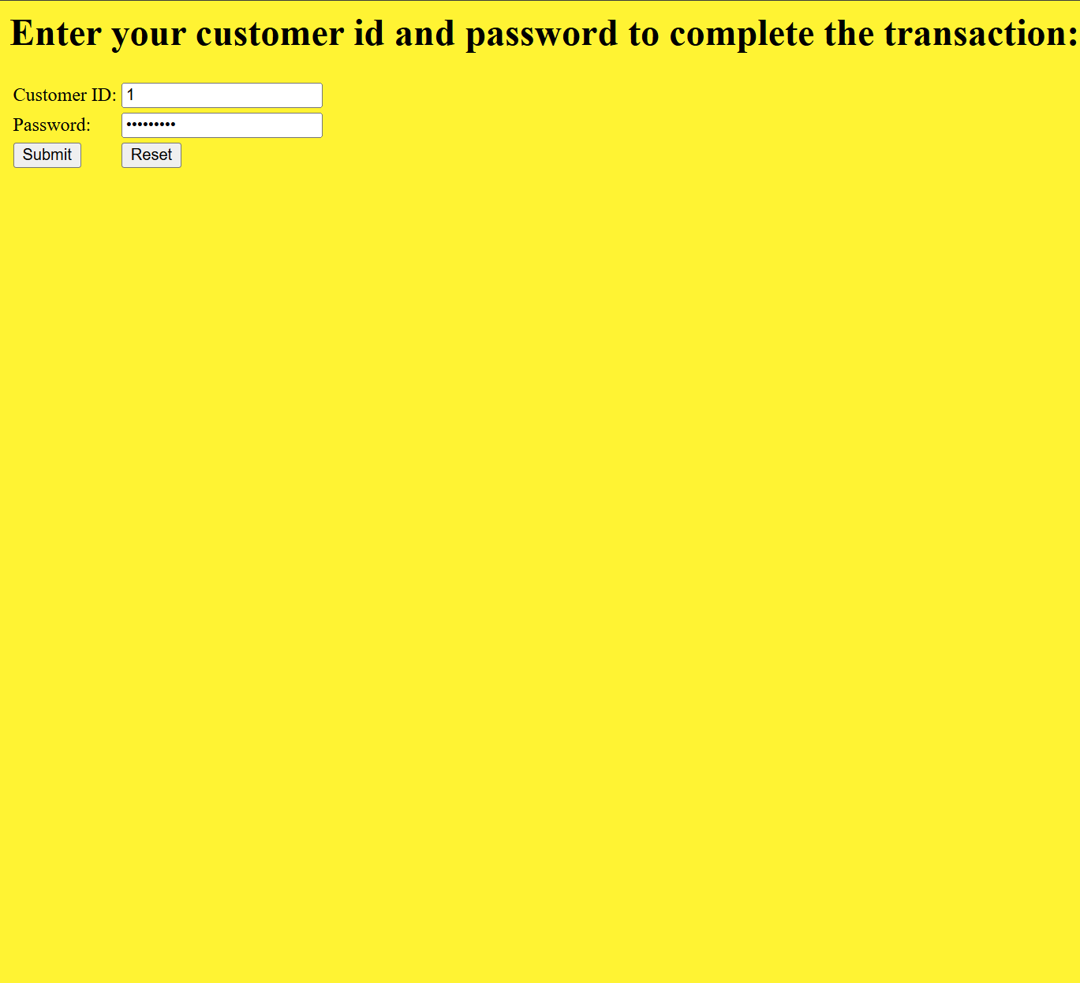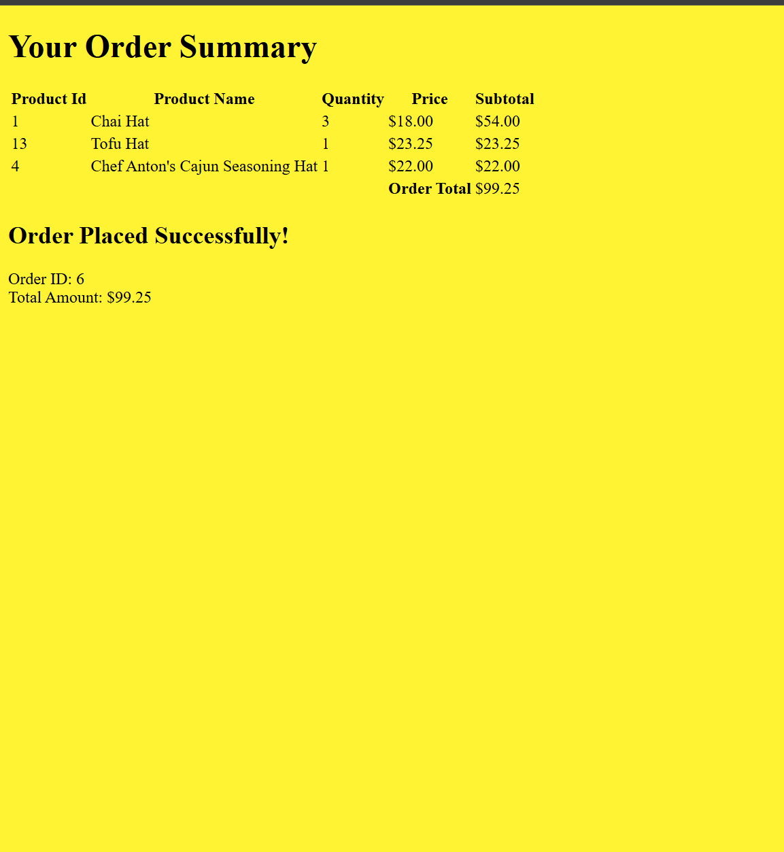
Back on the main screen, If a user clicks on the list all orders button they are shown a list of all the previous orders that have taken place on the website. This is in a table that shows the orderID, orderdate, customerID, Customername, Total amount, and then inside each order there is a list of each product with the product id, product name, quantity, and price. | 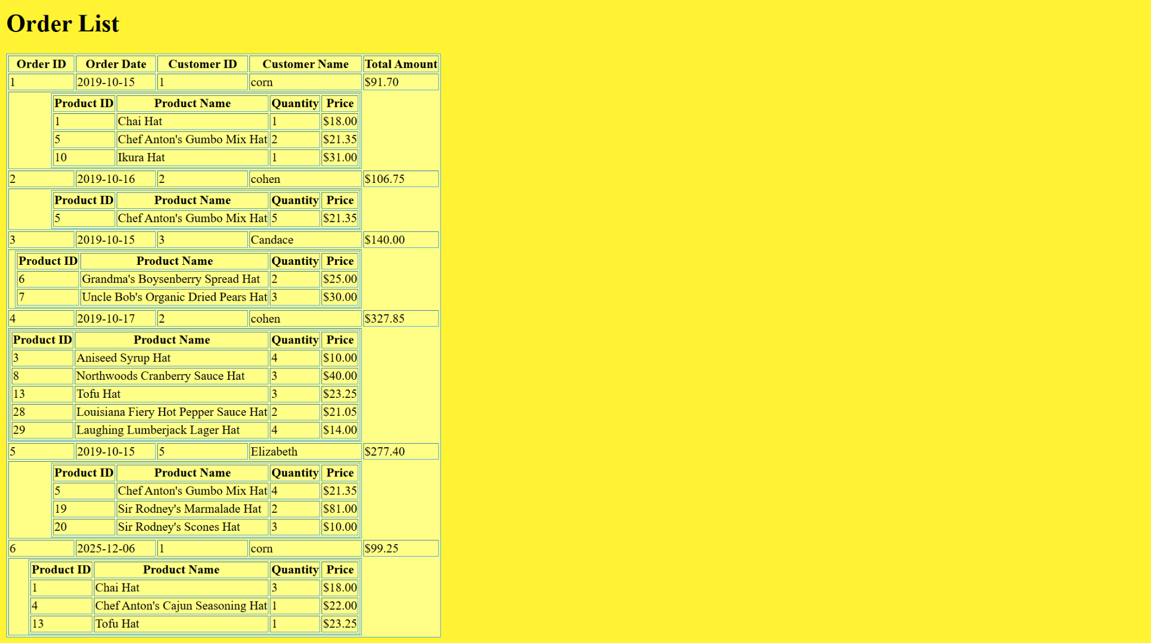
If the user clicks the customer info page and is logged in they are taken straight to it, however if they are not logged in they are instead redirected to the login screen and asked to login first. Once on the page the user can see all of the information about themselves. | 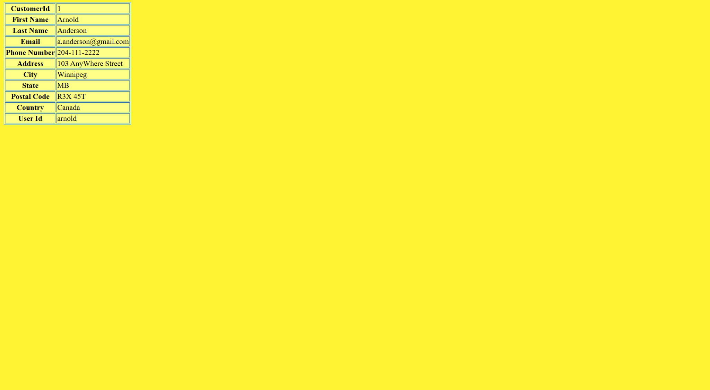
The administrators link has the same process with the customer info button where they have to be logged in. Once the user is there they can see a report by day of the daily sales. They can also see a button to add a new product. | 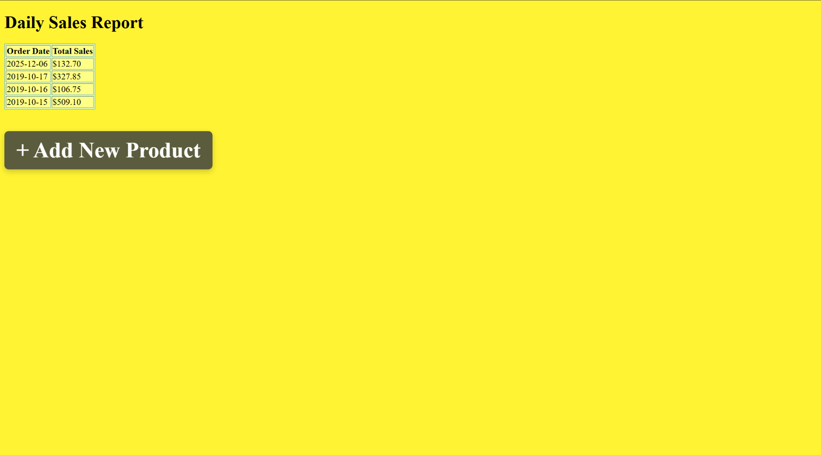
When the user clicks this button they are taken to the adding a new product page where they are prompted to add a name, price, description, and a dropdown menu for the category of item. Once they save the product it will appear on the product list for users shopping later | 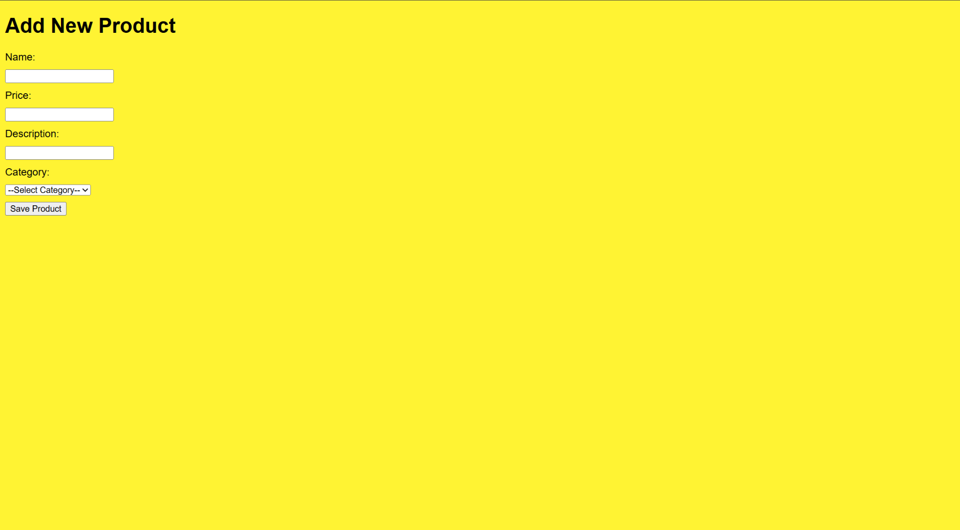
The logout button is pretty simple, it logs out the user.
The register new account button only appears if the user is not logged in, once clicked it takes the user to the register account page which prompts the user to enter a username and password. Once done it will prompt the user to log in with an option to go back to home | 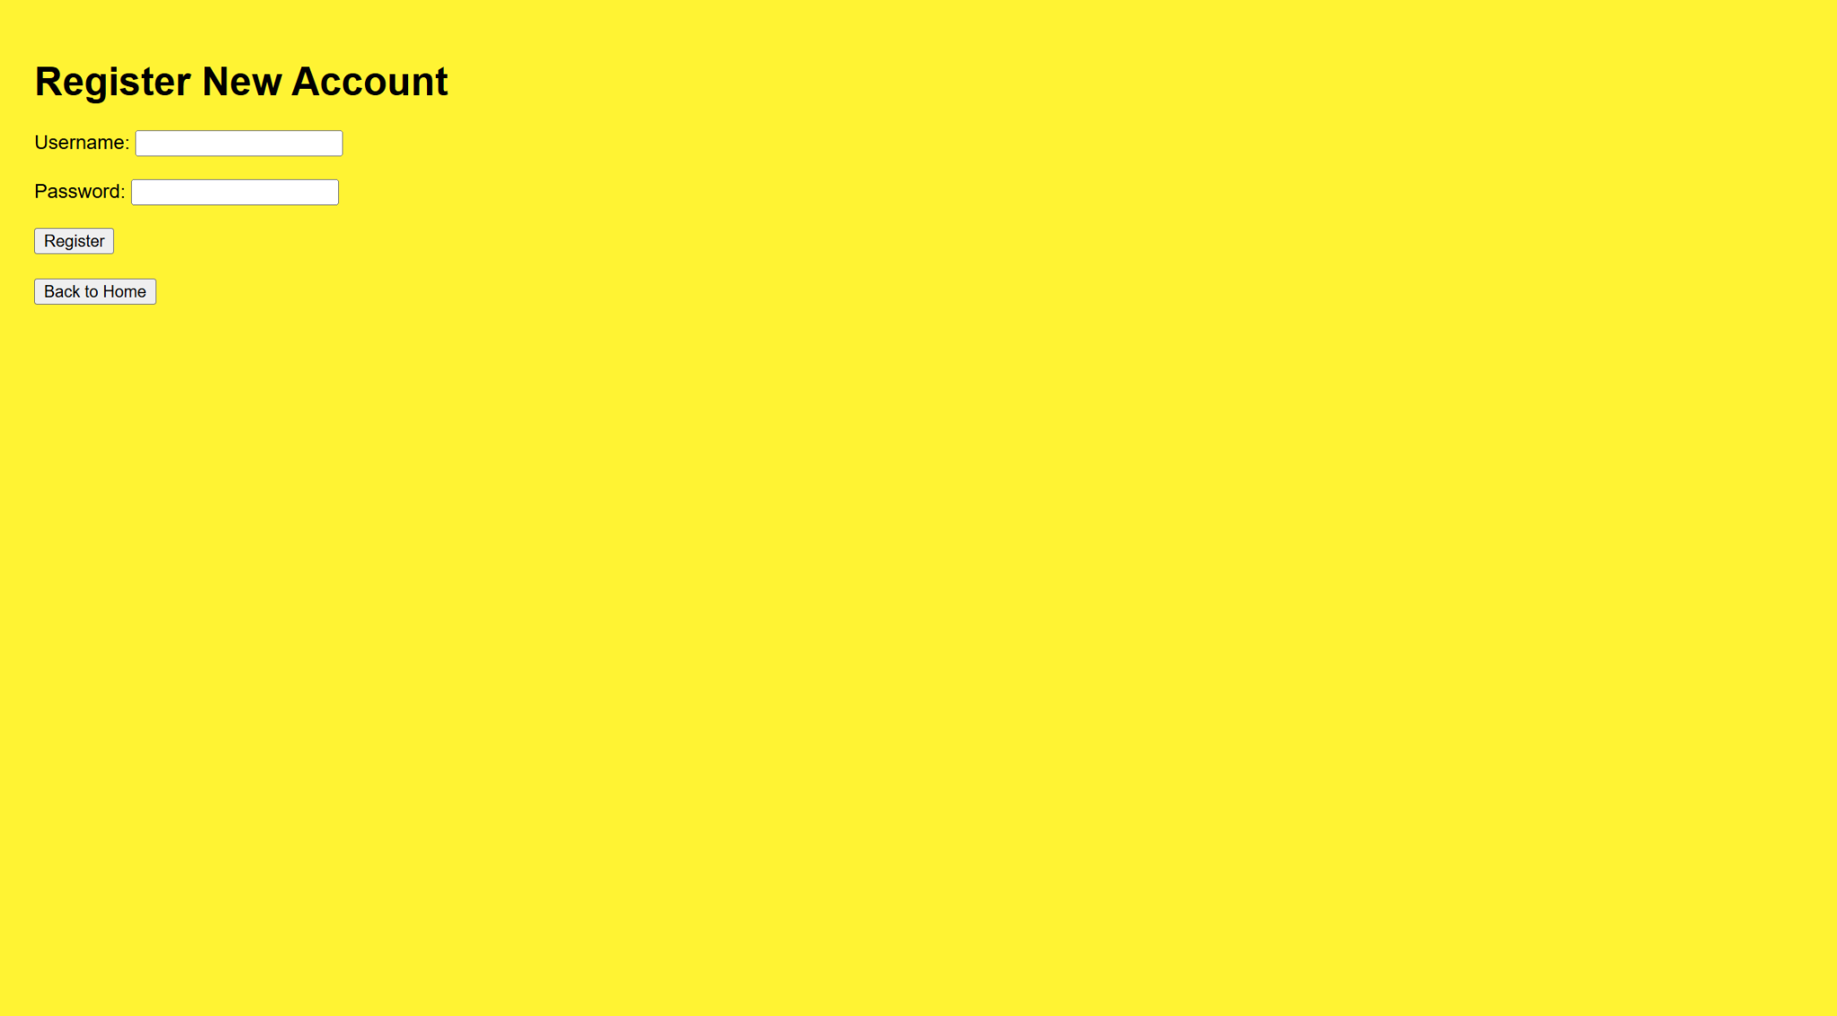
If the user is logged in, on the home screen there is an account management button that when clicked takes the user to an account management interface. One thing this page shows is an order history of all previous orders that this user has ordered. There is also an interface to change their username and one to change their password, if the user changes it it will be updated in the database | 